Given the root of a binary tree, return *the sum of all left leaves.*

A **leaf** is a node with no children. A **left leaf** is a leaf that is the left child of another node.

**Example 1:**

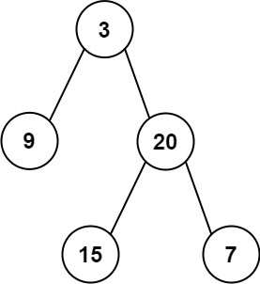

**Input:** root = [3,9,20,null,null,15,7]

**Output:** 24

**Explanation:** There are two left leaves in the binary tree, with values 9 and 15 respectively.

**Example 2:**

**Input:** root = [1]

**Output:** 0

**Constraints:**

* The number of nodes in the tree is in the range [1, 1000].
* -1000 <= Node.val <= 1000